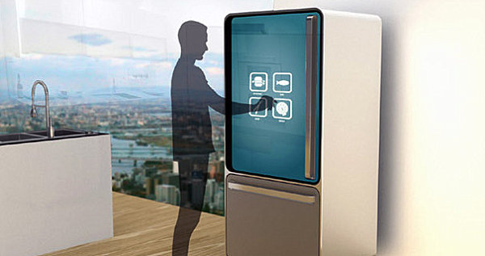

|  |  |
| --- | --- |
|  | Smart Refrigerator  *The first device of the smart kitchen - Seesam* |
|  | Tom Mampaey &  Bernd Verhofstadt  Bachelor Electronics – ICT  Erasmusstudents: Belgium  OAMK - University of Applied Sciences  5/1/15 |

Table of contents:

1. Introduction: 2

2. The project: 2

The Annex: 3

Content: 3

Images: 3

# Introduction:

We are both third-year students from ‘Artesis Plantijn Antwerp’ in Belgium. When we saw the opportunity to go on Erasmus to Oulu in Finland and do our Bachelor-project there we did everything to make it possible.   
Here we are, and we are very thrilled about the project we got!

# The project:

The project we are doing is a daughter-project of a bigger project of two years to put some intelligence into the ordinary kitchen (Seesam). We have the privilege to be the first two students to contribute to this project.

As stated in the title, we will delve us into the smart refrigerator!  
The main idea is to make a refrigerator that will know who’s using it, what he may and what he may not eat and what’s in the refrigerator.

# Github:

To maintain the structure, workflow and to easily monitor the project we have made a repository on Github for this project. Our request to make it private should be accepted soon. You can find the repository on:   
<https://github.com/TomMampaey/Smart-Fridge.git>

*Note: If you have a git-account we can add you to the view-members.*

1. The idea’s and brainstorm:

* User recognition:
  + **Fingerprint reader on handheld:**
  + **Active RFID key-hanger or card:**
  + **Kinect face-recognition:**
  + **Face-recognition Raspberry-Pi:**
  + **Voice-recognition:**
  + **Motion-detection:**

# The Annex:

Content:

Will be added soon.

Images:

* Front-page image:   
  <http://www.revistaexclusiva.com/?p=25851>